Satellite Academy Online Registration Guide

Welcome to our new campus records management system. This is a WebForm used by satellite academies to report basic training for newly-hired officers. It may be useful to have the applicant present while submitting this form. If you have already established a username and password with KLETC you may skip forward to step 3. If this is not the case, begin with step 1.

- Accessing the portal for the first time:
If the point of contact, who is usually an agency’s chief, sheriff or designated training coordinator, has not requested a registration portal account, please contact Angie Evans at 620-694-1528 or ajevans@kletc.org. Once the agency point of contact has contacted Angie to request a new account for our new online system, an email will be sent to the address used to sign up, which should look similar to the image below.
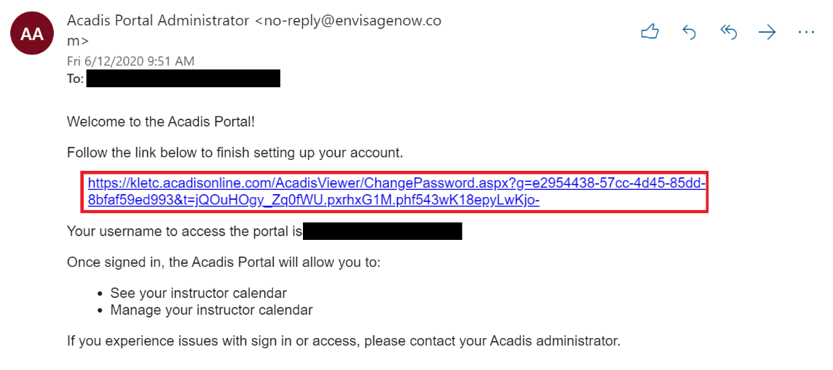
Click on the link to the website to begin the password reset process for the portal website. Your link will be unique and will expire over time. The username given to you is simply your email and can be used at any time after registration to sign into our online portal website.

- Password reset screen:
Here, you will be asked to create a password for the account. The password must follow the given guidelines to be valid.

Once your password has been reset, you will be taken to an end-user license agreement page. Read the terms and conditions and click “accept” to continue with the registration process. The agreement will only show during the initial signup.

- Normal Sign-In page:
First time users will not see this screen yet. Once the account has been activated and the password has been reset, you will be automatically signed in to the online registration portal and begin the process of requesting basic training (see step 4). For any sign-in after the first time, you will be taken to this login screen. You may want to bookmark it for future reference. On the left-hand side of the registration portal sign-in page, enter your new username found on the welcome email and your new password. This will take you to the homepage.
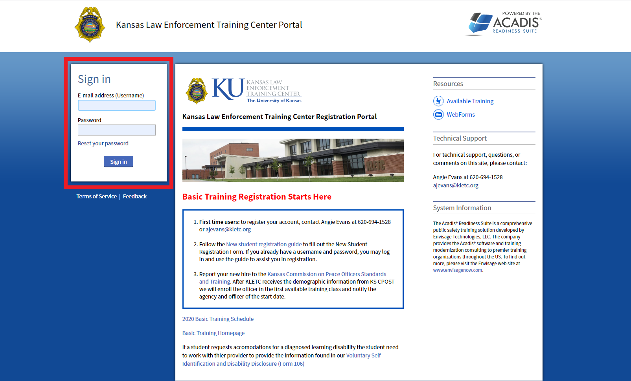

- Online Registration Portal Page:
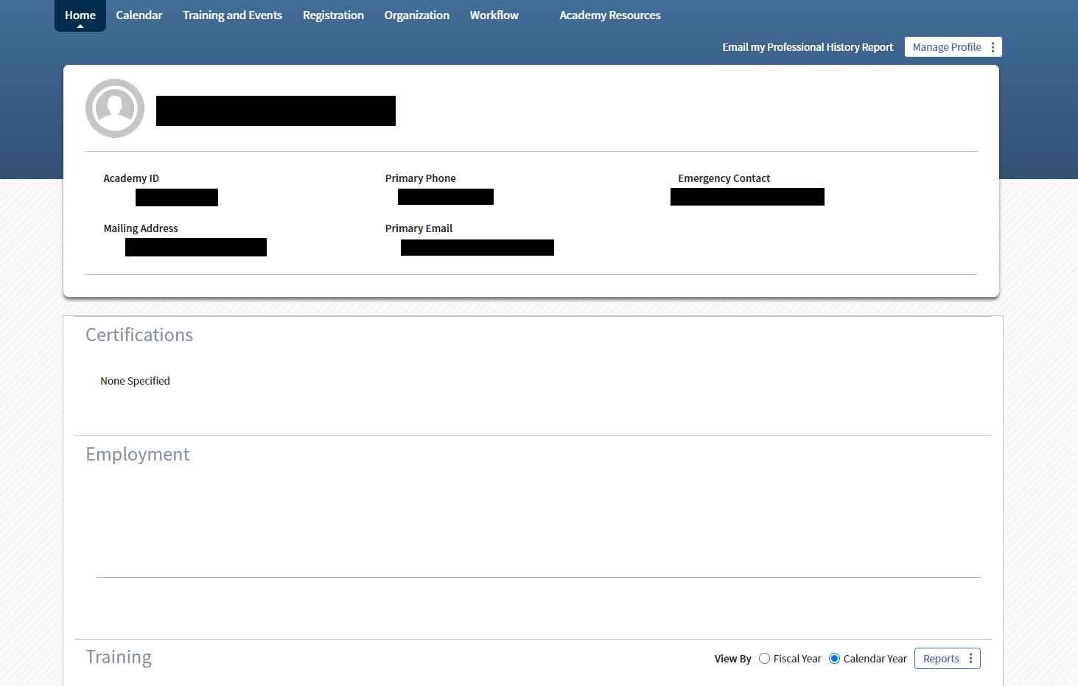
After you have entered a username and password, you will be taken to the online registration portal homepage. This is the first thing you will see every time you sign in.

- Academy Resources tab:
In order to start new student registration, click on the “Academy Resources” tab on the right side of the toolbar at the top of your screen.

This link will take you to a new page where you will begin the registration process.

- Academy Resources page:
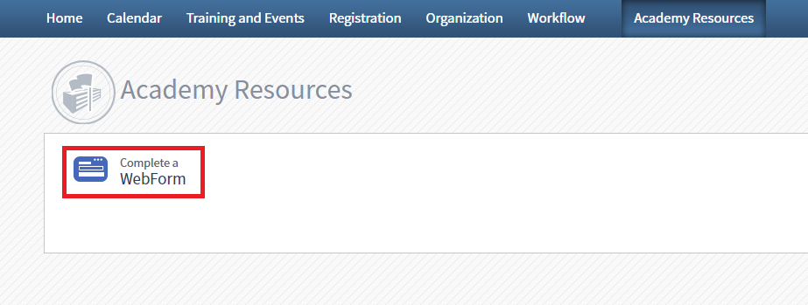
Clicking the “Complete a WebForm” link will take you to the next page.

- Full Time Basic Registration WebForm:
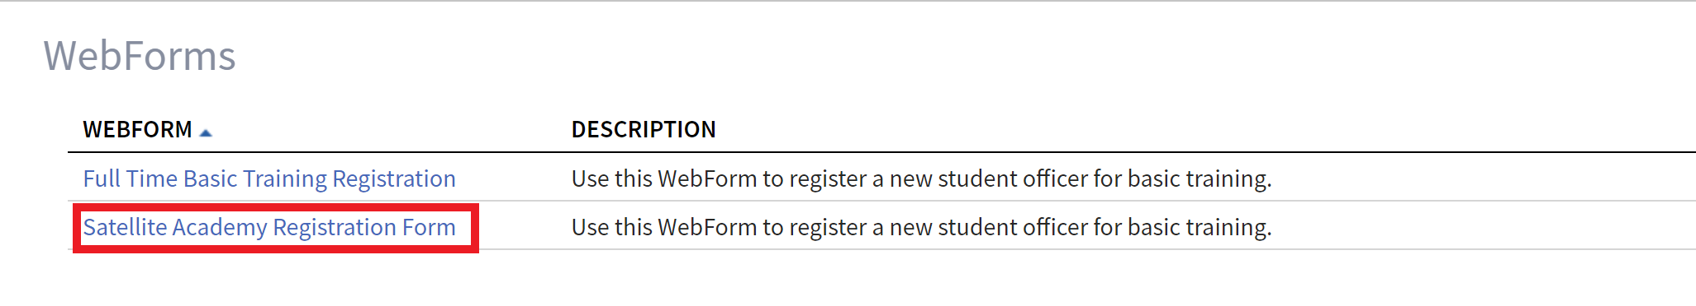
Here, select the “Satellite Academy Registration Form” link shown in the image below.

This will take you to the page where you will fill out the form. All fields with red asterisks are required for submission.

- Student Information:
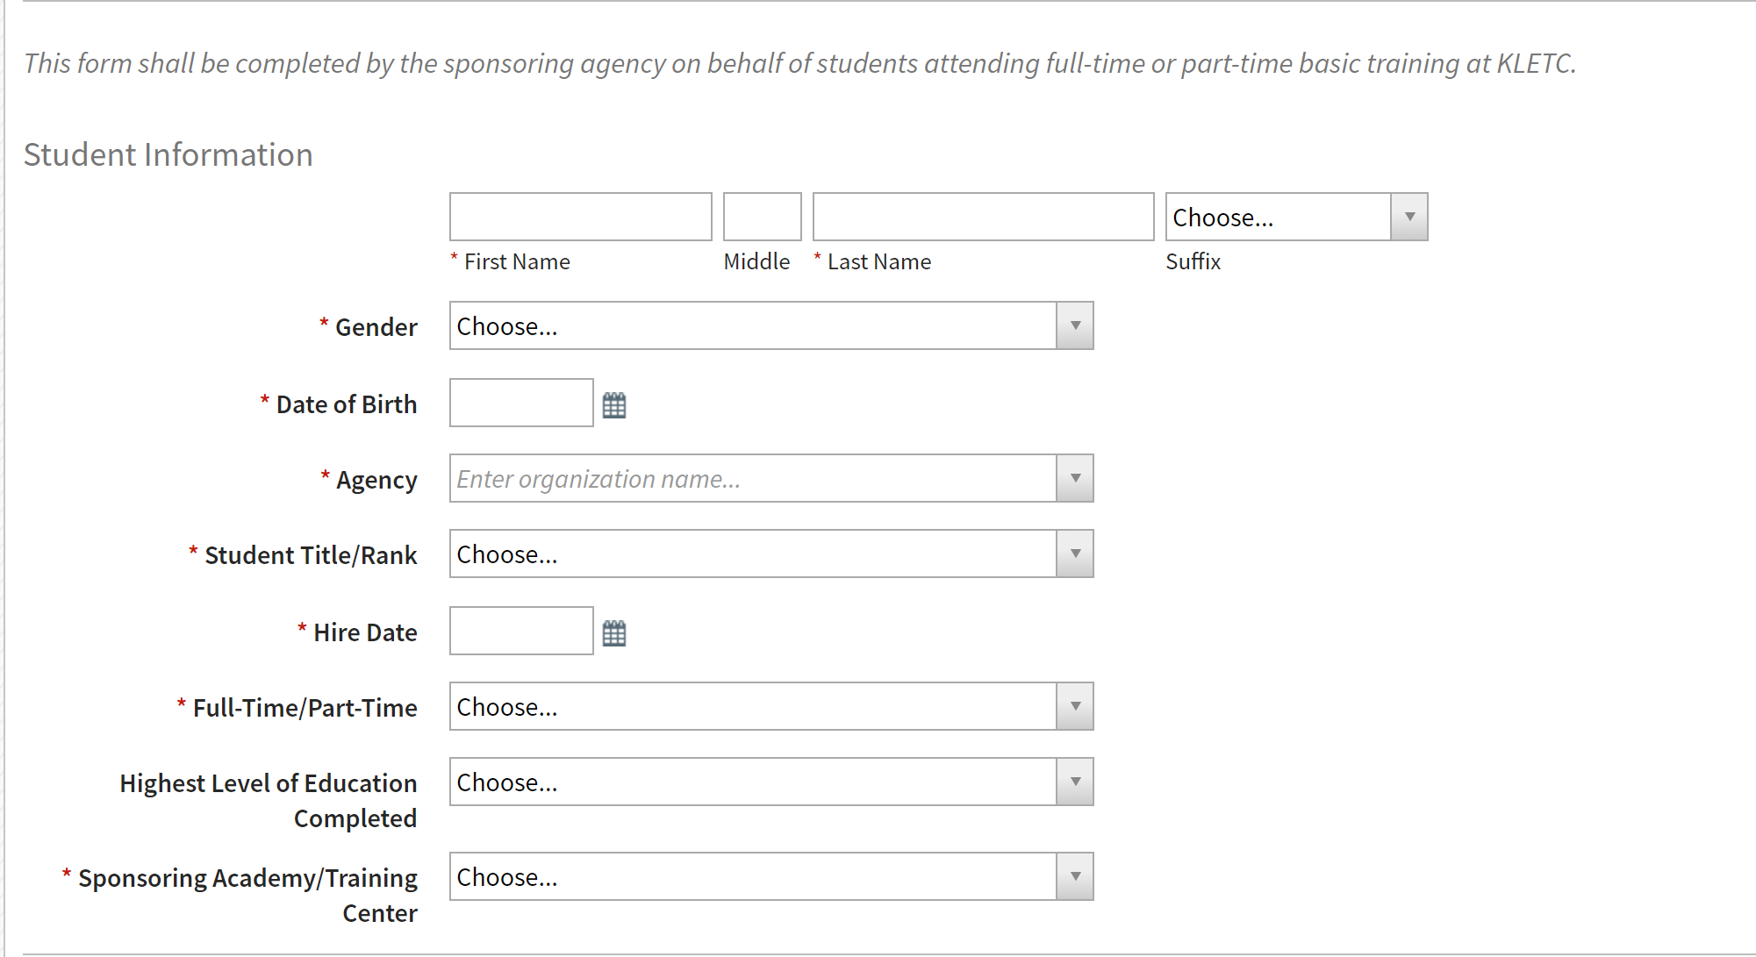
This section is basic information about the registering student.

- Physical Examination:
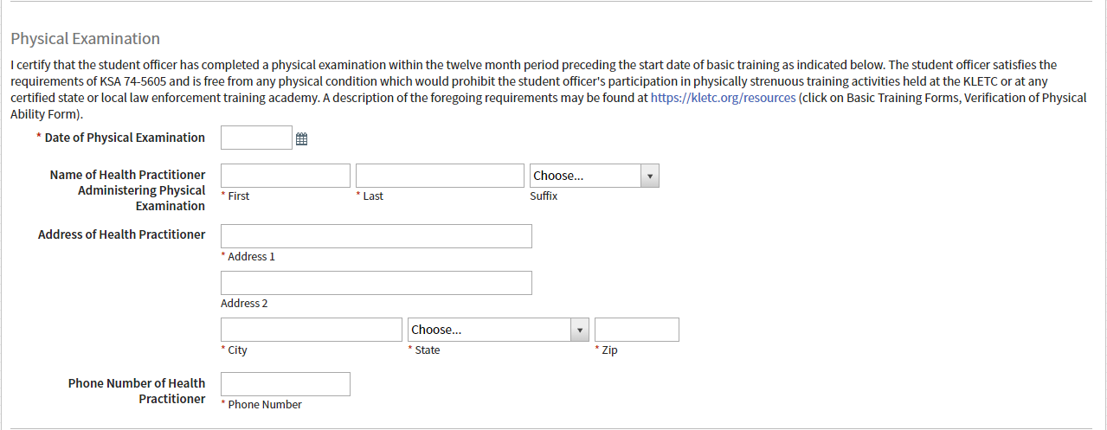
In this section, include confirmation and all necessary information to verify that the student has completed a physical examination within twelve months prior to beginning basic training and has met the physical requirements of KSA 74-5605.

- Psychological Examination:
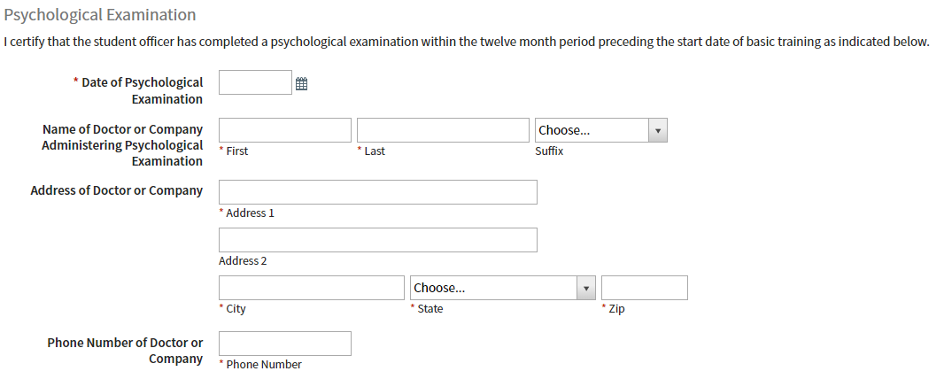
This section is similar to the above section. Enter the information to confirm that the student has undergone an appropriate psychological examination within twelve months prior to beginning basic training.

- Certification of Submission:
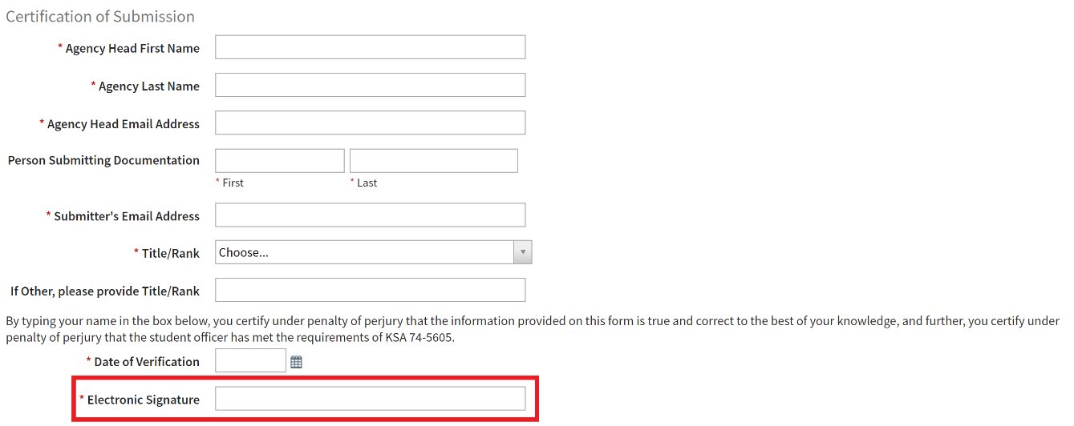
This section should be completed by the department head or the designee to certify that the information submitted is as complete and accurate as possible. By entering your name in the signature box, you are confirming that all above information is correct.

- Submit form:
Once you have entered all required fields and fully verified that all included information is correct, you may click the “Submit” button on the bottom-right corner of your screen.

This will submit the request for basic training. You should receive an email from the Kansas Law Enforcement Training Center confirming that we have received your request for a basic training slot. If you are having trouble finding the confirmation email, check your spam and junk folders. If you have clicked on the “Submit” button and nothing happens, please review the data you type in the page, you may have missed a required field.
Your officer has not yet been enrolled in a specific class. KLETC will confirm demographic submission with CPOST, then enroll your student in the appropriate class. If you have any questions regarding registrations, please contact the Karen Roberts, the KLETC registrar at 620-694-1521 or at kroberts@kletc.org.

