Basic Training Online Registration Guide

Welcome to our campus records management system. This is a WebForm used by agencies to request basic training for newly-hired officers. It may be useful to have the applicant present while submitting this form.

- Accessing the portal:
If the point of contact, who is usually an agency’s chief, sheriff or designated training coordinator, has not requested a registration portal account, please contact Christina Carmichael at 620-694-1524 or crcarmichael@kletc.org. Once the agency point of contact has contacted Angie to request a new account for our new online system, an email will be sent to the address used to sign up, which should look similar to the image below.
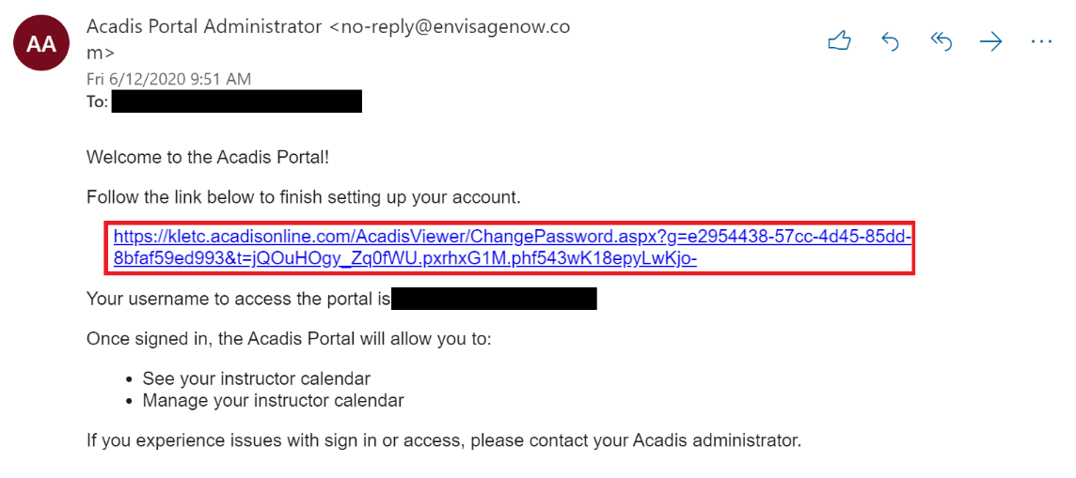
Click on the link to the website to begin the password reset process for the portal website. Your link will be unique and will expire over time. The username given to you is simply your email and can be used at any time after registration to sign into our online portal website.

- Password reset screen:
Here, you will be asked to create a password for the account. The password must follow the given guidelines to be valid.

Once your password has been reset, you will be taken to an end-user license agreement page. Read the terms and conditions and click “accept” to continue with the registration process.

- Later Sign-In page:
First time users will not see this screen yet. Once the account has been activated and the password has been reset, you will be automatically signed in to the online registration portal and begin the process of requesting basic training (see step 4). For any sign-in after the first time, you will be taken to this login screen. You may want to bookmark it for future reference. On the left-hand side of the registration portal sign-in page, enter your new username found on the welcome email and your new password. This will take you to the homepage.
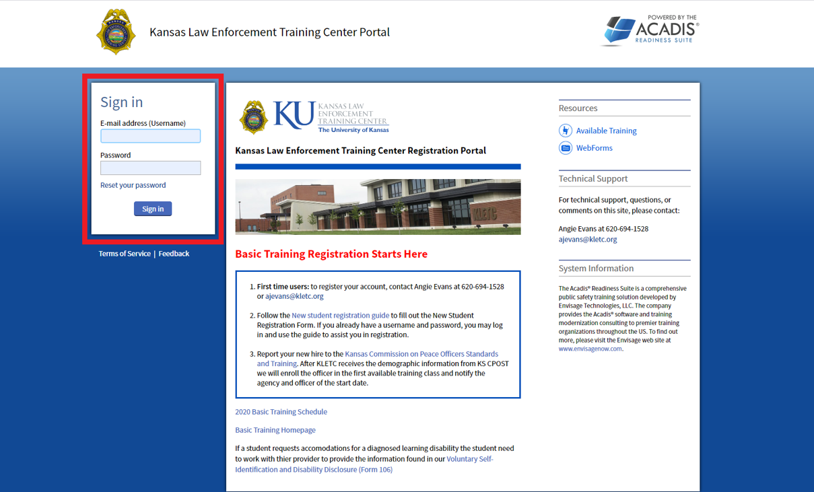

- First Time Sign-In and Online Registration Homepage:
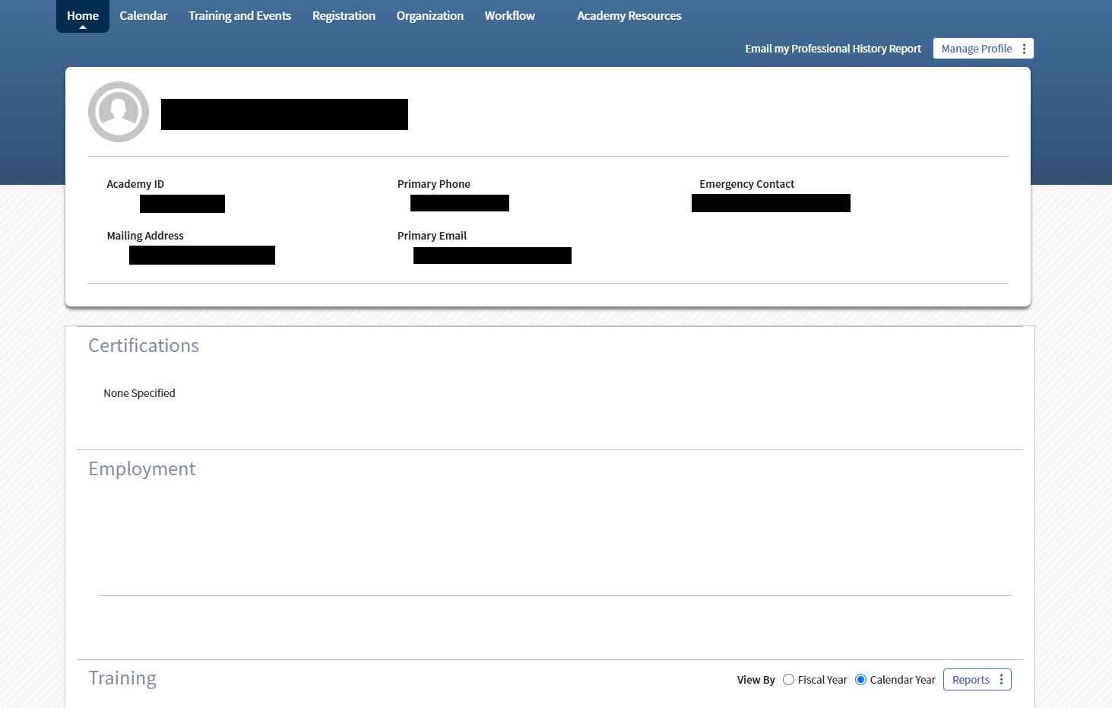After you have entered a username and password, you will be taken to the online registration portal homepage. This is the first thing you will see every time you sign in.

- Academy Resources tab:
In order to start new student registration, click on the “Academy Resources” tab on the right side of the toolbar at the top of your screen.

This link will take you to a new page where you will begin the registration process.

- Academy Resources page:
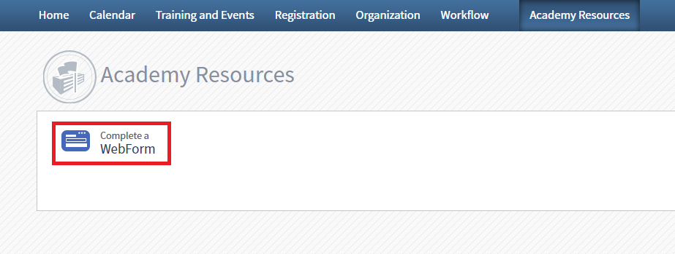Clicking the “Complete a WebForm” link will take you to the next page.

- Full Time Basic Registration WebForm:
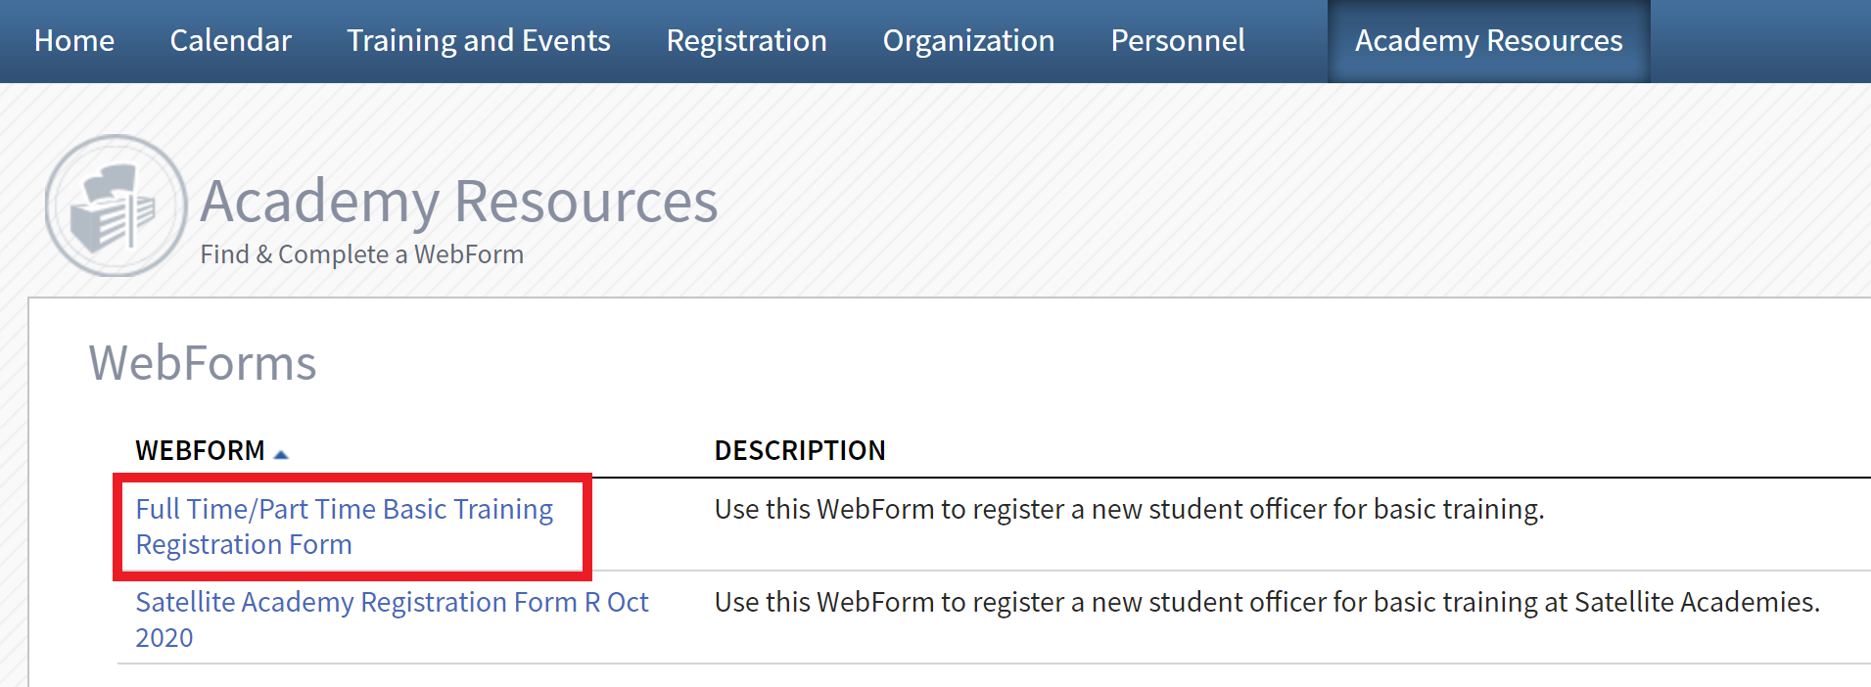Here, select the “Full Time/Part Time Basic Registration Form” link shown in the image below.

This will take you to the page where you will fill out the form. All fields with red asterisks are required for submission.

- Student Information:
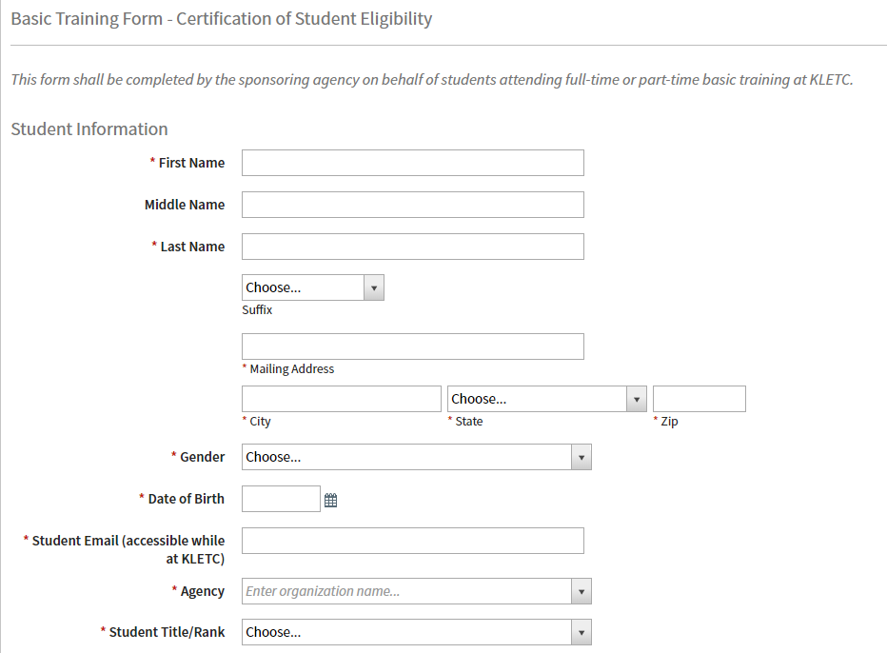This section is basic information about the registering student.

While it is not required for form submission, please include the student’s middle name if they have one. When filling out the Mailing Address section, use the student’s home address.
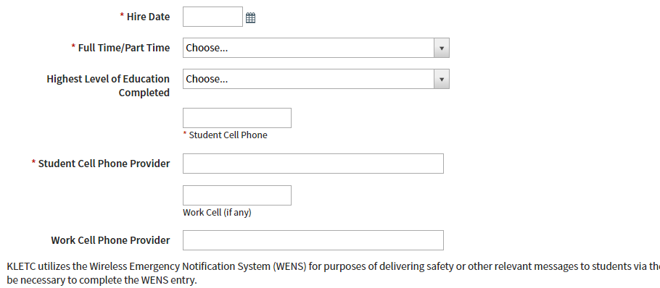
KLETC collects students’ cell phone information to use with the Wireless Emergency Notification System (WENS) for purposes of delivering safety or other relevant messages to students, please include the student’s work phone number and provider if applicable.

- Emergency contact information:
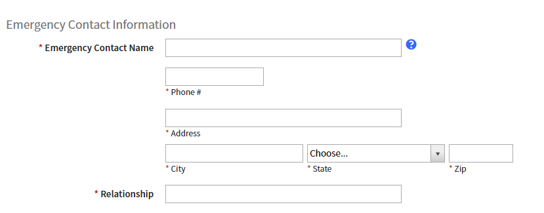The student’s chosen emergency contact information is entered here. All fields are required.
- First Aid/CPR/AED training:
If the agency would like to register the student for the First Aid/CPR/AED Training class that is available to all full-time basic training students, select the “Yes” option in the dropdown menu. If the student already has up-to-date training or plans on taking a class outside of basic training, the agency may select the “No” option. Be aware that if the student chooses not to take this class, the responsibility falls on their hiring agency to ensure they receive proper training.
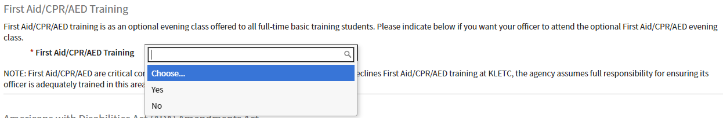

- Americans With Disabilities Act
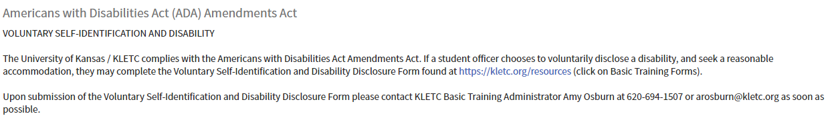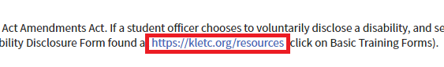If your student chooses to disclose a disability and seek accommodations, please follow the instructions outlined in the Americans with Disabilities Act Guide.

If your student does not choose to disclose a disability or seek accommodations for their disability, please continue on to step 11.

- Physical Examination:
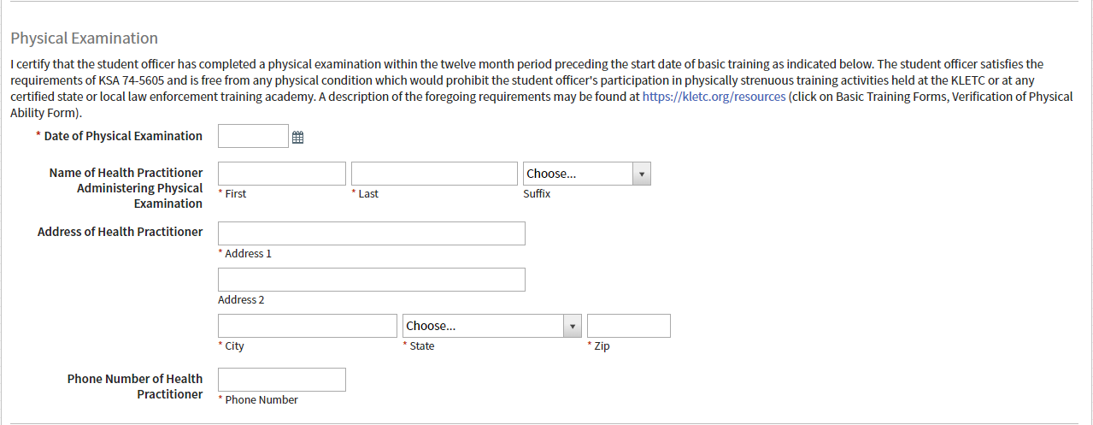In this section, include confirmation and all necessary information to verify that the student has completed a physical examination within twelve months prior to beginning basic training and has met the physical requirements of KSA 74-5605.

- Psychological Examination:
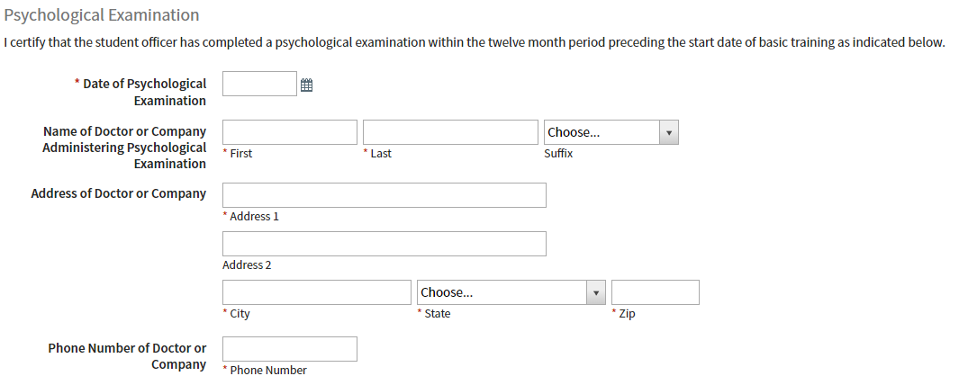This section is similar to the above section. Enter the information to confirm that the student has undergone an appropriate psychological examination within twelve months prior to beginning basic training.

- Student Uniforms
This section asks for clothing measurements for student uniforms while attending KLETC. KLETC bears the expense of the uniforms. The student officer will need a department uniform for graduation.
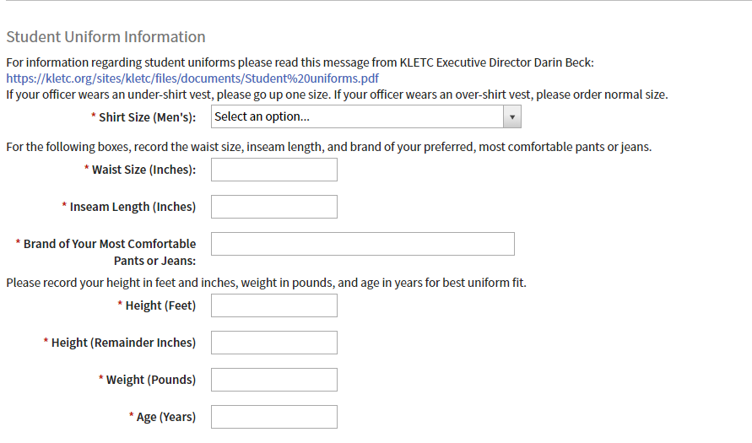
- Certification of Submission:
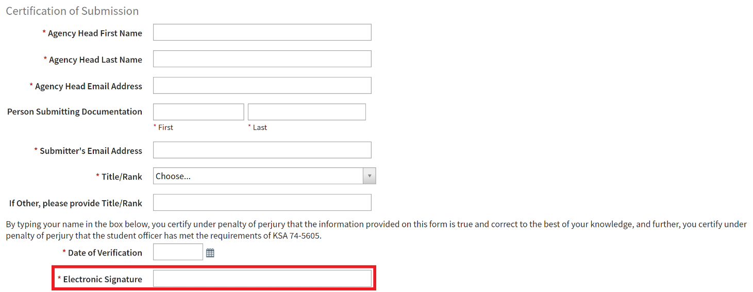This section should be completed by the department head or the designee to certify that the information submitted is as complete and accurate as possible. By entering your name in the signature box, you are confirming that all above information is correct.

- Submit form:
Once you have entered all required fields and fully verified that all included information is correct, you may click the “Submit” button on the bottom-right corner of your screen.

This will submit the request for basic training. You should receive an email from the Kansas Law Enforcement Training Center confirming that we have received your request for a basic training slot. If you are having trouble finding the confirmation email, check your spam and junk folders.
Your officer has not yet been enrolled in a specific class. KLETC will determine the first available class to enroll your student. You will soon receive additional emails letting you know the first available class in which your student will be enrolled. Now, you may return to the home page of our online service or fully sign out of your account.

